

DEPARTMENT OF COMPUTER SCIENCE AND ENGINEERING

Academic Year
2022 – 2023 (Odd Semester)

MINI PROJECT REPORT

U19CS202 Database Management Systems
&
U19CS203 Object-Oriented Programming

Vending Machine

Submitted by, Mentored by,
[21CS001] | Aarthi N
[21CS062] | Jaya Surya N
[21CS063] | Jeevananth P
[21CS064] | Jeevavarshini D
Giridharan R
Keerthika J
Assistant Professor,
Department of CSE

 | TABLE OF CONTENTS
CHAPTER NO. | TITLE |  |  |  | PAGE NO.
 | ABSTRACT |  |  |  | i
 | LIST OF TABLES |  |  |  | ii
 | LIST OF FIGURES |  |  |  | iii
1 | INTRODUCTION
 | 1.1 |  | OBJECTIVES
 | 1.2 |  | SCOPE OF THE PROJECT
2 | SYSTEM ANALYSIS AND SPECIFICATION
 | 2.1 |  | PROBLEM DESCRIPTION
 | 2.2 |  | FRONT END
 | 2.3 |  | BACK-END
3 | SYSTEM DESIGN
 | 3.1 |  | ER DIAGRAM
 | 3.2 |  | SCHEMA DIAGRAM
4 | PROPOSED SOLUTION
 | 4.1 OVERVIEW |  | USER INTERFACE DESIGN
 | 4.2 |  | CLASS CONSTRUCTION
 | 4.3 |  | DATABASE CREATION
5 |  | PROJECT DESCRIPTION
 |  | 5.1 |  | <<MODULE DESCRIPTION – Use your own Module Name>>
 |  |  |  | <<Add your module Description numbered like 5.1.1, 5.1.2, 5.1.3, etc >>
 |  | 5.2 |  | JDBC CONNECTIVITY
6 |  | IMPLEMENTATION
7 |  | RESULTS AND DISCUSSION
8 |  | CONCLUSION & FUTURE ENHANCEMENT
 |  | REFERENCES

ABSTRACT

CHAPTER 1
INTRODUCTION

  - OBJECTIVES
- AI personal assistant is an application program powered by Artificial Intelligence technology that can understand the voice commands and the text commands by the user and then fulfill the task assigned with the commands.
- It is also known as digital assistant or AI assistant. Siri, Google Assistant, Alexa, Cortona have become mainstream today, being used through smartphones and dedicated devices.
- For example, just say ‘OK GOOGLE’ on Android, or ‘HEY SIRI’ on an iPhone, and the devices will wait for your command.

  - SCOPE OF THE PROJECT
    - Businesses are using digital assistants to optimize the tasks that are traditionally handed to personal secretaries.
    - For instance, the digital assistants can perform almost every task of the human assistants, such as taking dictation, reading emails and text messages, finding phone numbers, shut down your laptop/ computer, finding the current location, setting reminder for meetings and appointments.
    - Furthermore, a personal AI can also help in various tasks. These tasks includes opening apps, launching windows apps, searching queries on Google, opening websites, reading out news, etc.

CHAPTER 2
SYSTEM ANALYSIS AND SPECIFICATION

2.1 PROBLEM DESCRIPTION
Working of Coffee Vending Machine
The system should provide the features of the following types of vending machines and their operations.
- Premix vending machines
- Espresso Coffee Vending
- Fresh Milk Coffee & Tea Vending Machines
- Bean to Coffee Vending Machine

2.2 FRONT END
- Processor Type : Core i3
- Speed : 3.40GHZ
- RAM : 4GB DD2 RAM
- Hard disk : 500 GB

2.3 BACK END
- MySQL Libraries
- MySQL Workbench
- Eclipse IDE Apache Tomcat Server
- Operating system : Windows10

CHAPTER 3
SYSTEM DESIGN

3.1 ER DIAGRAM
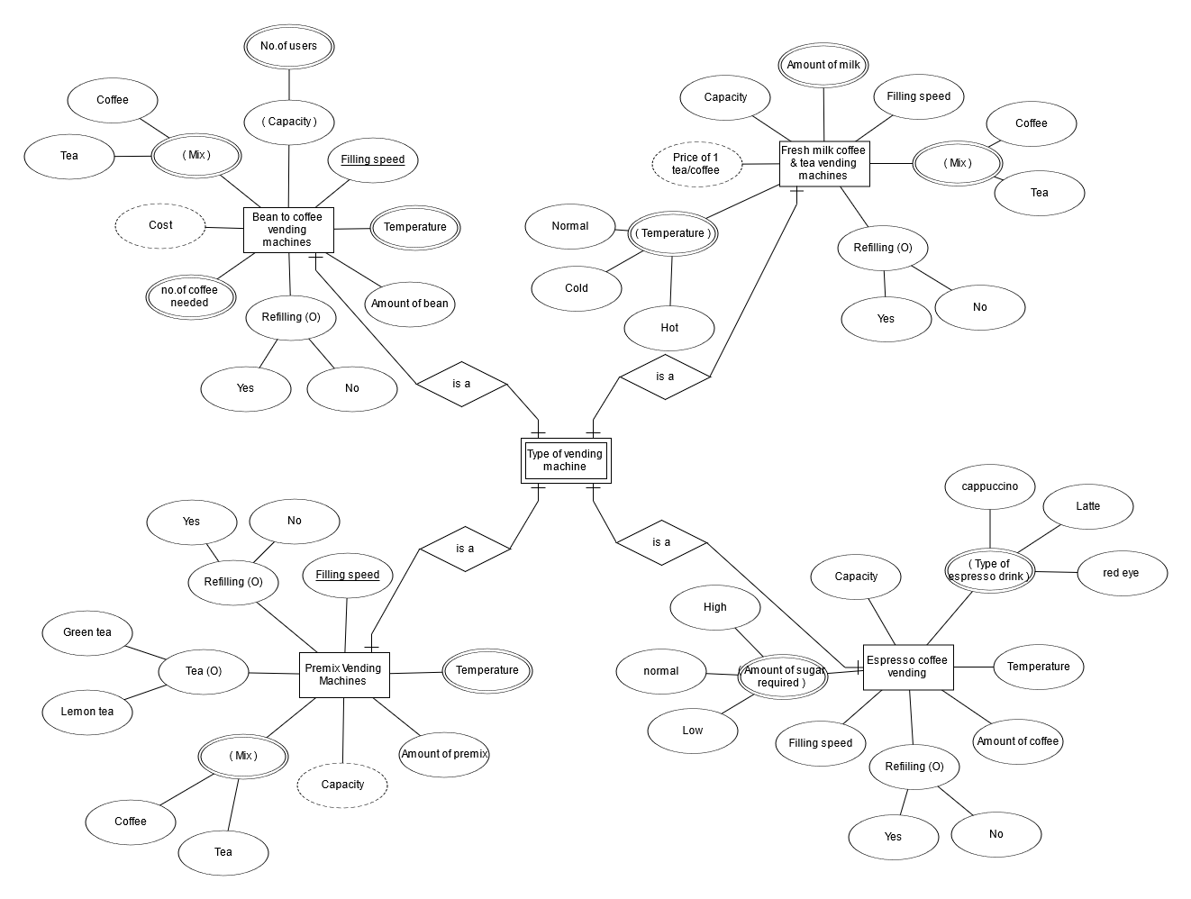
3.2 SCHEMA DIAGRAM
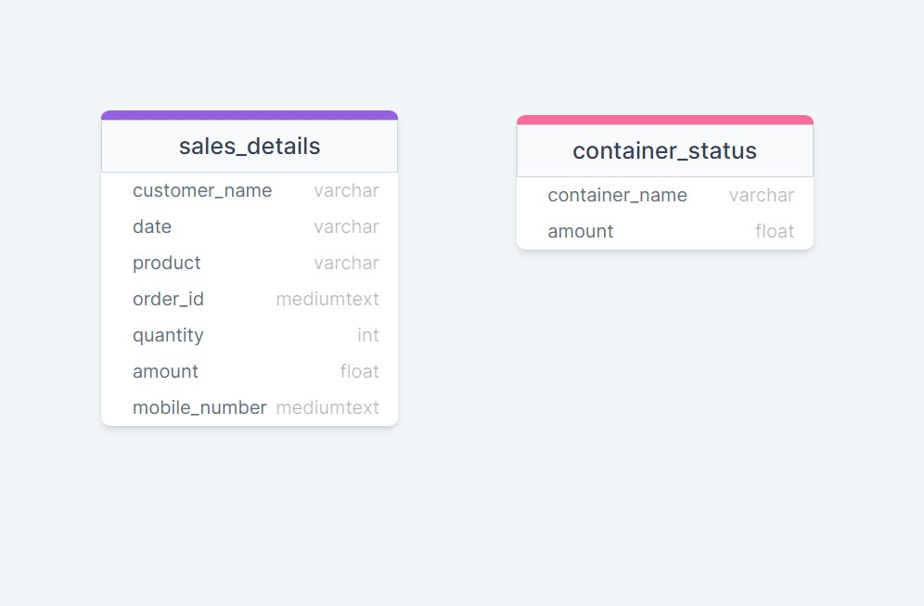

CHAPTER 4
PROPOSED SOLUTION

4.1 USER INTERFACE DESIGN

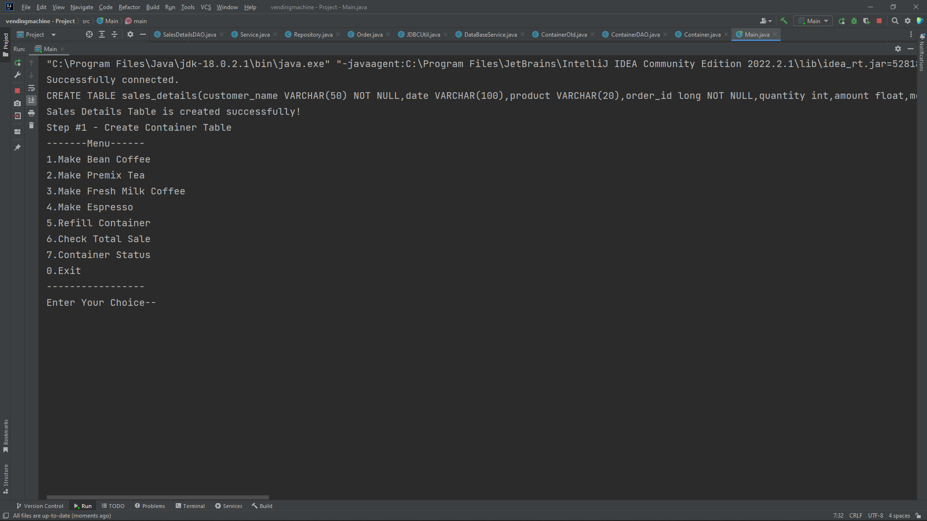

4.2 CLASS CONSTRUCTION
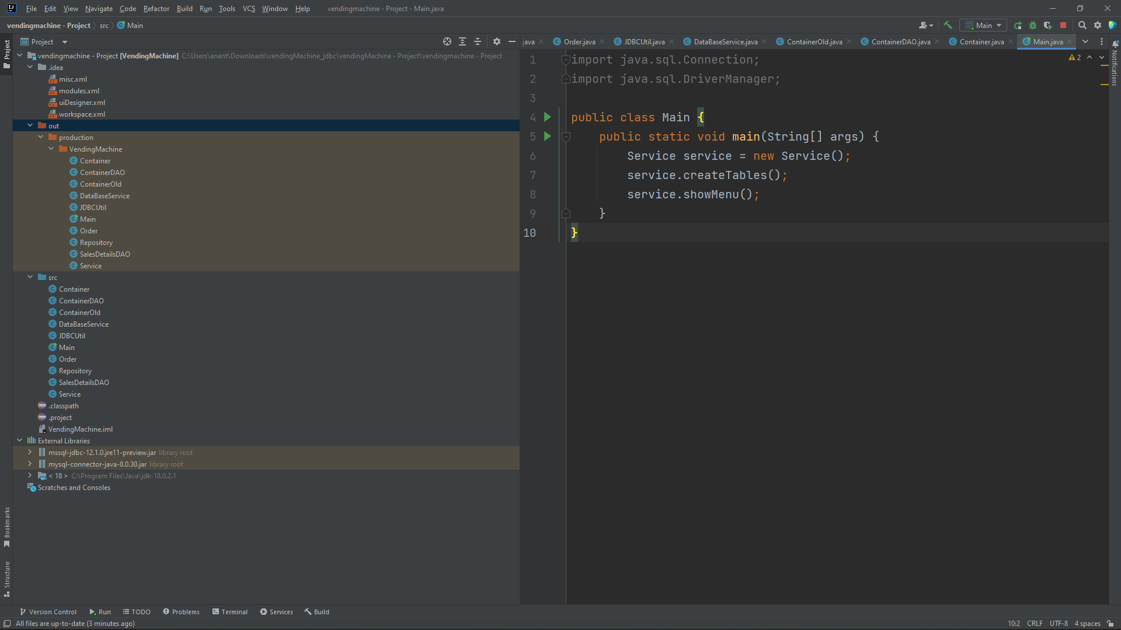

4.3 DATABASE CREATION
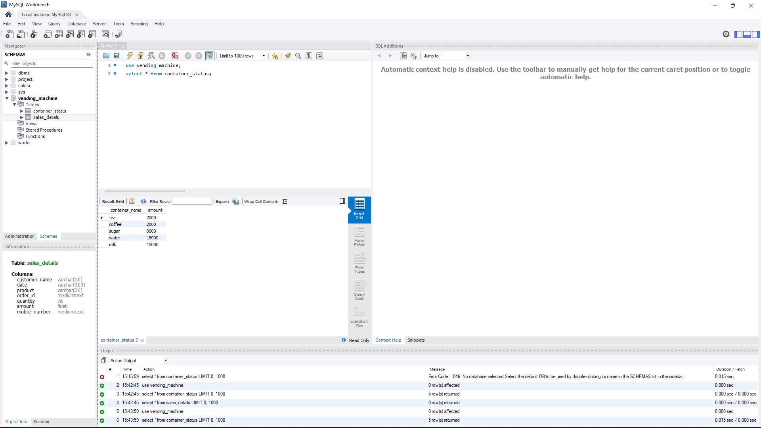

CHAPTER 5
PROJECT DESCRIPTION

5.1 MODULE DESCRIPTION
<?xml version="1.0" encoding="UTF-8"?>
<module type="JAVA_MODULE" version="4">
<component name="NewModuleRootManager" inherit-compiler-output="true">
<exclude-output />
<content url="file://$MODULE_DIR$">
<sourceFolder url="file://$MODULE_DIR$/src" isTestSource="false" />
</content>
<orderEntry type="inheritedJdk" />
<orderEntry type="sourceFolder" forTests="false" />
<orderEntry type="module-library" exported="">
<library>
<CLASSES>
<root url="jar://$USER_HOME$/Documents/JDBCRepo/mssql-jdbc-12.1.0.jre11-preview.jar!/" />
</CLASSES>
<JAVADOC />
<SOURCES />
</library>
</orderEntry>
<orderEntry type="module-library" exported="">
<library>
<CLASSES>
<root url="jar://$USER_HOME$/Documents/JDBCRepo/mysql-connector-java-8.0.30.jar!/" />
</CLASSES>
<JAVADOC />
<SOURCES />
</library>
</orderEntry>
</component>
</module>

5.2 JDBC CONNECTIVITY

import java.sql.Connection;
import java.sql.DriverManager;
import java.sql.SQLException;
import java.sql.Statement;
public class JDBCUtil {
private static final String DB_DRIVER =
"com.mysql.cj.jdbc.Driver";
private static final String DB_URL =
"jdbc:mysql://localhost:3306/vending_machine";
private static final String DB_USERNAME = "root";
private static final String DB_PASSWORD = "jeeva@17";
public static Connection getConnection(){
Connection conn = null;
try{
//Register the JDBC driver
Class.forName(DB_DRIVER);
//Open the connection
conn = DriverManager.getConnection(DB_URL, DB_USERNAME, DB_PASSWORD);
if(conn != null){
System.out.println("Successfully connected.");
}else{
System.out.println("Failed to connect.");
}
}catch(Exception e){
e.printStackTrace();;
}
return conn;
}
public static void closeConnection(Connection conn) {
try {
conn.close();
} catch (SQLException e) {
System.out.println("Data base connection is not closed");
e.printStackTrace();
}
}
public static void closeStatement(Statement st) {
try {
st.close();
} catch (SQLException e) {
System.out.println("Data base connection is not closed");
e.printStackTrace();
}
}
}

CHAPTER 6
IMPLEMENTATION

Paste your entire code here

public class Container {

private static String TEA_CONTAINER_VALUE = "tea";
private static String COFFEE_CONTAINER_VALUE = "coffee";
private static String SUGAR_CONTAINER_VALUE = "sugar";
private static String WATER_CONTAINER_VALUE = "water";
private static String MILK_CONTAINER_VALUE = "milk";
private Float tea_container = 2000.0F;
private Float coffee_container = 2000.0F;
private Float sugar_container = 8000.0F;
private Float water_container = 15000.0F;
private Float milk_container = 10000.0F;
public ContainerDAO containerDao;

public Container() {
containerDao = new ContainerDAO();
}

public void initiateContainer() {
containerDao.addValuesToContainerTable(tea_container, coffee_container, sugar_container, water_container, milk_container);
}

public Float getTea_container() {
tea_container = containerDao.retriveSingleContainerValue(TEA_CONTAINER_VALUE);
return tea_container;
}

public void setTea_container(Float tea_container) {
containerDao.updateIndividualContainer(TEA_CONTAINER_VALUE, tea_container);
this.tea_container = tea_container; // unnecessary since we are keeping the record in DB
}

public Float getCoffee_container() {
coffee_container = containerDao.retriveSingleContainerValue(COFFEE_CONTAINER_VALUE);
return coffee_container;
}

public void setCoffee_container(Float coffee_container) {
containerDao.updateIndividualContainer(COFFEE_CONTAINER_VALUE, coffee_container);
this.coffee_container = coffee_container;
}

public Float getSugar_container() {
sugar_container = containerDao.retriveSingleContainerValue(SUGAR_CONTAINER_VALUE);
return sugar_container;
}

public void setSugar_container(Float sugar_container) {
containerDao.updateIndividualContainer(SUGAR_CONTAINER_VALUE, sugar_container);
this.sugar_container = sugar_container;
}

public Float getWater_container() {
water_container = containerDao.retriveSingleContainerValue( WATER_CONTAINER_VALUE);
return water_container;
}

public void setWater_container(Float water_container1) {
System.out.println(water_container1);
containerDao.updateIndividualContainer(WATER_CONTAINER_VALUE, water_container1);
this.water_container = water_container1;
}

public Float getMilk_container() {
milk_container = containerDao.retriveSingleContainerValue(MILK_CONTAINER_VALUE);
return milk_container;
}

public void setMilk_container(Float milk_container) {
containerDao.updateIndividualContainer(MILK_CONTAINER_VALUE, milk_container);
this.milk_container = milk_container;
}

public Container(Float tea_container, Float coffee_container, Float sugar_container, Float water_container, Float milk_container) {
System.out.println("The unused function is finally used !!!!!!!");
this.tea_container = tea_container;
this.coffee_container = coffee_container;
this.sugar_container = sugar_container;
this.water_container = water_container;
this.milk_container = milk_container;
}

}

public class ContainerDAO { // Should be an interface and Implementation

private DataBaseService dataBaseService = new DataBaseService();
private String retriveContainerQuery = "SELECT amount FROM container_status WHERE container_name='%s'";
private String updateContainerQuery = "UPDATE container_status SET amount=%s WHERE container_name ='%s'";
private String tableName = "container_status";

public ContainerDAO() {
}

public void createContainerTable() {

System.out.println("Step #1 - Create Container Table");
String ContainerQuery =

"CREATE TABLE container_status("
+ "container_name varchar(20),"
+ "amount float)";
dataBaseService.execute(ContainerQuery);
}

public void addValuesToContainerTable(Float tea_container, Float coffee_container, Float sugar_container, Float water_container, Float milk_container) {

String teaContainer = "INSERT INTO container_status(container_name,amount) "
+ "VALUES('tea',"
+ tea_container + ")";
dataBaseService.insertToTable(teaContainer);

String coffeeContainer = "INSERT INTO container_status(container_name,amount) "
+ "VALUES('coffee',"
+ coffee_container + ")";
dataBaseService.insertToTable(coffeeContainer);

String sugarContainer = "INSERT INTO container_status(container_name,amount) "
+ "VALUES('sugar',"
+ sugar_container + ")";
dataBaseService.insertToTable(sugarContainer);

String waterContainer = "INSERT INTO container_status(container_name,amount) "
+ "VALUES('water',"
+ water_container + ")";
dataBaseService.insertToTable(waterContainer);

String milkContainer = "INSERT INTO container_status(container_name,amount) "
+ "VALUES('milk',"
+ milk_container + ")";
dataBaseService.insertToTable(milkContainer);
}

public float retriveSingleContainerValue(String containerType) {
System.out.println(String.format(retriveContainerQuery, containerType));
return dataBaseService.retriveSingleRecord(String.format(retriveContainerQuery, containerType)); // should I send this as float instead of string in a query ?

}

public void updateIndividualContainer(String containerType, Float value) {
String query = String.format(updateContainerQuery, value, containerType);
dataBaseService.updateRecord(query);
}

public void deleteContainerTable() {
dataBaseService.deleteTable(tableName);
}

}

import java.sql.Connection;
import java.sql.PreparedStatement;
import java.sql.ResultSet;
import java.sql.SQLException;
import java.sql.Statement;
import java.util.ArrayList;
import java.util.List;

public class DataBaseService { //This contains multiple tables so Didn't create TableNameDAO class & Interface for specific Tables

public static Connection dataBaseConnection; // is this public static ? private ? should be created in diff class

static {
JDBCUtil jdbcUtil = new JDBCUtil();
dataBaseConnection = JDBCUtil.getConnection();

}

// JDBCUtil jdbcUtil = new JDBCUtil();
private String DELETE_TABLE_QUERY = "DROP TABLE ";

public DataBaseService() {
// dataBaseConnection = JDBCUtil.getConnection();
}

public void execute(String query) {
try {
Statement statement = dataBaseConnection.createStatement();
statement.execute(query);
JDBCUtil.closeStatement(statement);
// ---------------- dataBaseConnection.close();---------------------- // Close it in the end
}
catch(SQLException e){
e.printStackTrace();
}

}

public void insertToTable(String insertQuery) {
try {
// PreparedStatement prep = dataBaseConnection.prepareStatement(insertQuery);
//prep.setFloat(1, 1.0);
Statement statement = dataBaseConnection.createStatement();
statement.executeUpdate(insertQuery);
JDBCUtil.closeStatement(statement);
// ---------------- dataBaseConnection.close();---------------------- // Close it in the end
}
catch(SQLException e){
e.printStackTrace();
}

}

public float retriveSingleRecord(String query) {
ResultSet data = null;
float record = 0F;
try {
Statement statement = dataBaseConnection.createStatement();
data = statement.executeQuery(query);
data.next();
// System.out.println("OUT" + data.getFloat("amount"));

record = data.getFloat(1);
JDBCUtil.closeStatement(statement);
}
catch(SQLException e) {
e.printStackTrace();
}
return record;
}

public void updateRecord(String query) {
try {
Statement statement = dataBaseConnection.createStatement();
statement.executeUpdate(query);
JDBCUtil.closeStatement(statement);
}
catch(SQLException e) {
e.printStackTrace();
}
}

public ResultSet retriveTableOfData(String query) {
ResultSet retrivedData = null;
try {
Statement statement = dataBaseConnection.createStatement();
retrivedData = statement.executeQuery(query);
}
catch(SQLException e) {
e.printStackTrace();
}
return retrivedData;
}

public void closeDataBaseConnection() {
try {
JDBCUtil.closeConnection(dataBaseConnection);
dataBaseConnection.close();
} catch (SQLException e) {
e.printStackTrace();
}
}

public void deleteTable(String tableName) {

try {
Statement statement = dataBaseConnection.createStatement();
statement.executeUpdate(DELETE_TABLE_QUERY+tableName);
JDBCUtil.closeStatement(statement);
} catch (SQLException e) {
e.printStackTrace();
}
}

}

import java.sql.Connection;
import java.sql.DriverManager;
import java.sql.SQLException;
import java.sql.Statement;

public class JDBCUtil {
private static final String DB_DRIVER =
"com.mysql.cj.jdbc.Driver";
private static final String DB_URL =
"jdbc:mysql://localhost:3306/vending_machine";
private static final String DB_USERNAME = "root";
private static final String DB_PASSWORD = "jeeva@17";

public static Connection getConnection(){
Connection conn = null;
try{
//Register the JDBC driver
Class.forName(DB_DRIVER);

//Open the connection
conn = DriverManager.getConnection(DB_URL, DB_USERNAME, DB_PASSWORD);

if(conn != null){
System.out.println("Successfully connected.");
}else{
System.out.println("Failed to connect.");
}
}catch(Exception e){
e.printStackTrace();;
}
return conn;
}

public static void closeConnection(Connection conn) {
try {
conn.close();
} catch (SQLException e) {
System.out.println("Data base connection is not closed");
e.printStackTrace();
}
}

public static void closeStatement(Statement st) {
try {
st.close();
} catch (SQLException e) {
System.out.println("Data base connection is not closed");
e.printStackTrace();
}
}

}

import java.sql.Connection;
import java.text.SimpleDateFormat;
import java.util.Date;

class Order {

private Long orderId = System.currentTimeMillis();
private Integer productId;
private String productName;
private Float amount;
SimpleDateFormat formatter = new SimpleDateFormat("dd/MM/yyyy HH:mm:ss");
Date date1 = new Date();
private String date = formatter.format(date1);
private Integer quantity;
private String customerName;
private Long CustomerMobileNo;
public SalesDetailsDAO salesDetailsDao = new SalesDetailsDAO();

public Order() {
}

public Long getOrderId() {
return orderId;
}

public void setOrderId(Long orderId) {
this.orderId = orderId;
}

public Integer getProductId() {
return productId;
}

public void setProductId(Integer productId) {
this.productId = productId;
}

public Float getAmount() {
return amount;
}

public void setAmount(Float amount) {
this.amount = amount;
}

public SimpleDateFormat getFormatter() {
return formatter;
}

public void setFormatter(SimpleDateFormat formatter) {
this.formatter = formatter;
}

public Date getDate1() {
return date1;
}

public void setDate1(Date date1) {
this.date1 = date1;
}

public String getDate() {
return date;
}

public void setDate(String date) {
this.date = date;
}

public Integer getQuantity() {
return quantity;
}

public void setQuantity(Integer quantity) {
this.quantity = quantity;
}

public String getCustomerName() {
return customerName;
}

public void setCustomerName(String customerName) {
this.customerName = customerName;
}

public Long getCustomerMobileNo() {
return CustomerMobileNo;
}

public void setCustomerMobileNo(Long CustomerMobileNo) {
this.CustomerMobileNo = CustomerMobileNo;
}

public String getProductName() {
return productName;
}

public void setProductName(String productName) {
this.productName = productName;
}

public Order(String productName,Integer productId, Float amount, Integer quantity, String customerName, Long customerMobileNo) {
this.productName = productName;
this.productId = productId;
this.amount = amount;
this.quantity = quantity;
this.customerName = customerName;
this.CustomerMobileNo = customerMobileNo;
}

public void recordOrderData(Order currentOrder) {
salesDetailsDao.InsertInToSalesDetailsTable(currentOrder.productName, currentOrder.productId, currentOrder.amount, currentOrder.quantity, currentOrder.customerName, currentOrder.CustomerMobileNo,currentOrder.date,currentOrder.orderId);
}
}

import java.util.ArrayList;
import java.util.List;

public class Repository {

public List<Container> container = new ArrayList();

public List<Order> orderList = new ArrayList();

private static Repository repository; //Private constructor to restrict object creation from Outside.

private Repository(){
}

public static Repository getRepository(){
if(repository==null){
repository = new Repository();
}
return repository;
}
}
import java.sql.Connection;
import java.sql.ResultSet;
import java.sql.SQLException;
import java.util.ArrayList;
import java.util.List;

public class SalesDetailsDAO {

private DataBaseService dataBaseService = new DataBaseService();
private List<Order> totalSalesList = new ArrayList();
private String tableName = "sales_details";

public void createSalesDetailsTable() {

String salesDetailQuery =

"CREATE TABLE sales_details("
+ "customer_name VARCHAR(50) NOT NULL,"
+ "date VARCHAR(100),"
+ "product VARCHAR(20),"
+ "order_id long NOT NULL,"
+ "quantity int,"
+ "amount float,"
+ "mobile_number long"
+ ")";

System.out.println(salesDetailQuery);

dataBaseService.execute(salesDetailQuery);
System.out.println("Sales Details Table is created successfully!");
}

public void InsertInToSalesDetailsTable(String productName,Integer productId, Float amount, Integer quantity, String customerName, Long customerMobileNo, String date,Long orderId) {
String query = "INSERT INTO sales_details(customer_name,date,product,order_id,quantity,amount,mobile_number) "
+ "VALUES('"+ customerName + "'"
+ ",'" + date + "'"
+ ",'" + productName + "'"
+ "," + orderId
+ "," + quantity
+ "," + amount
+ "," + customerMobileNo + ")";
System.out.println(query);

dataBaseService.insertToTable(query);
}

public List<Order> retriveSalesDetails() {
ResultSet retrivedData;
String query = "SELECT * FROM sales_details";
retrivedData = dataBaseService.retriveTableOfData(query);

try {
while(retrivedData.next()) {
Order order = new Order();
order.setAmount(retrivedData.getFloat("amount"));
order.setCustomerMobileNo(retrivedData.getLong("mobile_number"));
order.setCustomerName(retrivedData.getString("customer_name"));
order.setDate(retrivedData.getString("date"));
order.setOrderId(retrivedData.getLong("order_id"));
order.setProductName(retrivedData.getString("product"));
order.setQuantity(retrivedData.getInt("quantity"));

totalSalesList.add(order);
}
} catch (SQLException e) {
e.printStackTrace();
}

return totalSalesList;
}

public void deleteSalesDetailsTable() {
dataBaseService.deleteTable(tableName);
}

}

import java.sql.Connection;
import java.sql.DriverManager;
import java.sql.PreparedStatement;
import java.sql.ResultSet;
import java.sql.Statement;
import java.util.List;
import java.util.Scanner;

public class Service {

Repository repo = Repository.getRepository();
Container cont = new Container();
ContainerDAO containerDao = new ContainerDAO();
public DataBaseService databaseService = new DataBaseService();
public Order order = new Order(); // To create Table
SalesDetailsDAO salesDetailsDAO = new SalesDetailsDAO();
private Integer counter =0;

private int choice;
Scanner in = new Scanner(System.in);

public void createTables() {
salesDetailsDAO.createSalesDetailsTable();
containerDao.createContainerTable();
cont.initiateContainer();
}

public void showMenu(){
while(true){
printMenu();
switch (choice) {
case 1 -> onMakeBeanCoffee();
case 2 -> onMakePremixTea();
case 3 -> onMakeFreshMilkCoffee();
case 4 -> onMakeEspresso();
case 5 -> onRefillContainer();
case 6 -> onCheckTotalSale();
case 7 -> onContainerStatus();
case 0 -> {
System.out.println("Thank You For Using Our Service. ");
containerDao.deleteContainerTable();
salesDetailsDAO.deleteSalesDetailsTable();
databaseService.closeDataBaseConnection();
System.exit(0);
}
}
}
}
/**
* This method Prints a Menu
*/
public void printMenu(){
System.out.println("-------Menu------");
System.out.println("1.Make Bean Coffee");
System.out.println("2.Make Premix Tea");
System.out.println("3.Make Fresh Milk Coffee");
System.out.println("4.Make Espresso");
System.out.println("5.Refill Container ");
System.out.println("6.Check Total Sale ");
System.out.println("7.Container Status ");
System.out.println("0.Exit");
System.out.println("----------------- ");
System.out.print("Enter Your Choice--");
choice=in.nextInt();
}

/**
* This Method will Make BeanCoffee for the User.
*/
public void onMakeBeanCoffee(){
in.nextLine();
System.out.println("Welcome! Please Enter Your Name");
String customerName = in.nextLine();
Integer productId = 1;
String productName = "Bean Coffee";
System.out.println("Nice to meet you " + customerName +"!, Please Enter Your Mobile Number ");
Long customerMobile = in.nextLong();
System.out.println("How Many Cups of Coffee Do You Want to Order");
int coffeeQuantity = in.nextInt();
Float amount = coffeeQuantity*15.0F;

if(cont.getCoffee_container()>(5*coffeeQuantity) && cont.getWater_container()>(23*coffeeQuantity) &&
cont.getMilk_container()>(88*coffeeQuantity) && cont.getSugar_container()>(17*coffeeQuantity)){ //Aarthi - isn't it >= ? getCoffeeContainer()>= ?

Order order = new Order(productName,productId,amount,coffeeQuantity,customerName,customerMobile);
order.recordOrderData(order);
System.out.println("Order values are recorded to Sales Table");

System.out.println("Taking Your Order Please Wait for a while");

System.out.println("Your Order is Ready. Please pay Rs."+amount+".");

cont.setCoffee_container(cont.getCoffee_container() - coffeeQuantity*5);
cont.setWater_container(cont.getWater_container() - coffeeQuantity*23);
cont.setMilk_container(cont.getMilk_container() - coffeeQuantity*88);
cont.setSugar_container(cont.getSugar_container() - coffeeQuantity*17);

}else{
System.out.println("Sorry Your Order cannot be processed because of Insufficient Raw Material.");
}
}
/**
* This Method will Make Premix Tea for the User.
*/
private void onMakePremixTea() {
in.nextLine();

System.out.println("Welcome, Please Enter Your Name");
String customerName = in.nextLine();
Integer productId = 2;
String productName = "Premix Tea";
System.out.println("Please Enter Your Mobile Number ");
Long customerMobile = in.nextLong();
System.out.println("How Many Cups of Tea Do You Want to Order");
int teaQuantity = in.nextInt();
Float amount = teaQuantity*10.0F;

if(cont.getTea_container()>(6*teaQuantity) && cont.getWater_container()>(65*teaQuantity) &&
cont.getMilk_container()>(44*teaQuantity) && cont.getSugar_container()>(17*teaQuantity)){

Order order = new Order(productName,productId,amount,teaQuantity,customerName,customerMobile);
order.recordOrderData(order);
System.out.println("Order values are recorded to Sales Table");

System.out.println("Taking Your Order Please Wait for a while");

System.out.println("Your Order is Ready. Please pay Rs."+amount+".");

cont.setCoffee_container(cont.getCoffee_container() - 0);
cont.setWater_container(cont.getWater_container() - teaQuantity*65);
cont.setMilk_container(cont.getMilk_container() - teaQuantity*44);
cont.setSugar_container(cont.getSugar_container() - teaQuantity*17);
cont.setTea_container(cont.getTea_container() - teaQuantity*6);

}else{
System.out.println("Sorry Your Order cannot be processed because of Insufficient Raw Material.");
}
}
/**
* This Method will Fresh milk Coffee for the User.
**/
private void onMakeFreshMilkCoffee() {
in.nextLine();

System.out.println("Welcome, Please Enter Your Name");
String customerName = in.nextLine();
Integer productId = 3;
String productName = "Fresh Milk Coffee";
System.out.println("Please Enter Your Mobile Number ");
Long customerMobile = in.nextLong();
System.out.println("How Many Cups of Fresh Milk Coffee Do You Want to Order");
int freshMilkCoffeeQuantity = in.nextInt();
Float amount = freshMilkCoffeeQuantity*10.0F;

if(cont.getCoffee_container()>=(3*freshMilkCoffeeQuantity) && cont.getWater_container()>=(42*freshMilkCoffeeQuantity) &&
cont.getMilk_container()>=(110*freshMilkCoffeeQuantity) && cont.getSugar_container()>=(17*freshMilkCoffeeQuantity)){

Order order = new Order(productName,productId,amount,freshMilkCoffeeQuantity,customerName,customerMobile);
order.recordOrderData(order);
System.out.println("Order values are recorded to Sales Table");

System.out.println("Taking Your Order Please Wait for a while");

System.out.println("Your Order is Ready. Please pay Rs."+amount+".");

cont.setCoffee_container(cont.getCoffee_container() - freshMilkCoffeeQuantity*3);
cont.setWater_container(cont.getWater_container() - freshMilkCoffeeQuantity*42);
cont.setMilk_container(cont.getMilk_container() - freshMilkCoffeeQuantity*110);
cont.setSugar_container(cont.getSugar_container() - freshMilkCoffeeQuantity*17);
cont.setTea_container(cont.getTea_container() - 0);

}else{
System.out.println("Sorry Your Order cannot be processed because of Insufficient Raw Material.");
}
}
/**
* This Method will Make Espresso for the User
*/
private void onMakeEspresso() {
in.nextLine();

System.out.println("Welcome, Please Enter Your Name");
String customerName = in.nextLine();
Integer productId = 4;
String productName = "Espresso";
System.out.println("Please Enter Your Mobile Number ");
Long customerMobile = in.nextLong();
System.out.println("How Many Cups of Espresso Do You Want to Order");
int espressoQuantity = in.nextInt();
Float amount = espressoQuantity*20.0F;

if(cont.getCoffee_container()>=(15*espressoQuantity) && cont.getWater_container()>=(20*espressoQuantity) &&
cont.getMilk_container()>=(120*espressoQuantity) && cont.getSugar_container()>=(20*espressoQuantity)){

Order order = new Order(productName,productId,amount,espressoQuantity,customerName,customerMobile);
order.recordOrderData(order);
System.out.println("Order values are recorded to Sales Table");

System.out.println("Taking Your Order Please Wait for a while");

System.out.println("Your Order is Ready. Please pay Rs."+amount+".");

cont.setCoffee_container(cont.getCoffee_container() - espressoQuantity*15);
cont.setWater_container(cont.getWater_container() - espressoQuantity*20);
cont.setMilk_container(cont.getMilk_container() - espressoQuantity*120);
cont.setSugar_container(cont.getSugar_container() - espressoQuantity*20);
cont.setTea_container(cont.getTea_container() - 0);

}else{
System.out.println("Sorry Your Order cannot be processed because of Insufficient Raw Material.");
}
}
/**
* This Method will Refill The Container
*/

private void onRefillContainer() {
cont.setCoffee_container(2000.0F);
cont.setTea_container(2000.0F);
cont.setSugar_container(8000.0F);
cont.setWater_container(15000.0F);
cont.setMilk_container(1000.0F);

counter = counter + 1;
System.out.println("Container Refilled Successful");
System.out.println("Container Refilled "+counter+" Times.");
}

/**
* This Method will Show the Individual Sales List of each Order
*/
private void onCheckTotalSale() {

System.out.println("Total Sales Report ");
List<Order> orderList= salesDetailsDAO.retriveSalesDetails();
System.out.println("Size" + orderList.size());
for(int i=0;i<orderList.size();i++){
Order o = orderList.get(i);
System.out.println((i+1)+". Customer Name:"+o.getCustomerName()+
"\n Date:"+o.getDate()+"\n Product:"+o.getProductName()+
"\n Quantity:"+o.getQuantity()+"\n Amount:"+o.getAmount()+"\n Mobile:"+o.getCustomerMobileNo()+
"\n Order Id:"+o.getOrderId());
}
}

/**
* This Method Shows the Quantity Available of The Container used to Prepare Drinks
*/
private void onContainerStatus() {
System.out.println("Container Status:");
System.out.println("Coffee Container = "+cont.getCoffee_container()+" Grams");
System.out.println("Tea Container = "+cont.getTea_container()+" Grams");
System.out.println("Sugar Container = "+cont.getSugar_container()+" Grams");
System.out.println("Milk Container = "+cont.getMilk_container()+" ml");
System.out.println("Water Container = "+cont.getWater_container()+" ml");
}

// public void writeToCustomerTable(String customerName, String)

}

import java.sql.Connection;
import java.sql.DriverManager;

public class Main {
public static void main(String[] args) {
Service service = new Service();
service.createTables();
service.showMenu();
}
}

CHAPTER 7
RESULTS AND DISCUSSIONS

Paste your screenshots along with the Description.
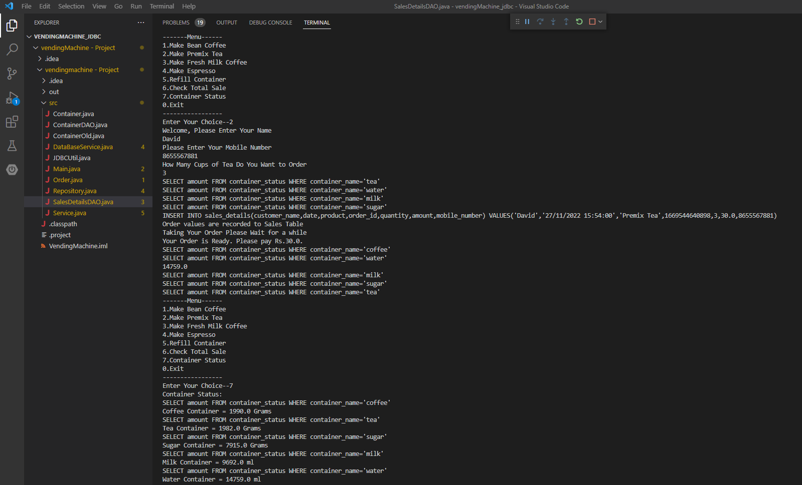

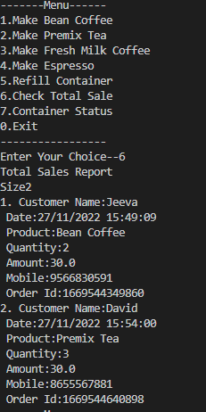

CHAPTER 8
CONCLUSION AND FUTURE ENHANCEMENT

AI virtual assistants are evolving quickly. Companies are enabling them to provide more capabilities like speech recognition and natural language processing advances. It will enable them to understand and perform requests. Furthermore, improvements in voice recognition technology are allowing them to move deeper into business workflows. In the future, AI assistants will have more advanced cognitive computing technologies. These will help them carry out multi-step requests and perform more complex tasks.

REFERENCES

[1] https://www.youtube.com/watch?v=dH-5UMpntJc
[2] https://www.programming9.com/programs/java/344-java-code-for-coffee-machine
[3] https://github.com/devesh096/Tea-Coffee-Vending-Machine---Core-Java-Project-/tree/master/TCVMApp_New/src/com/cricfann
[4] https://www.youtube.com/watch?v=AP_2XsRR-fI

